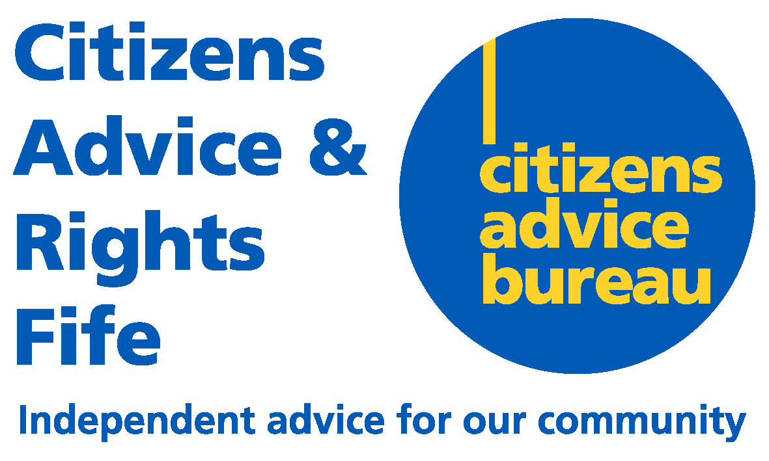 | Registered Office  Units 7 & 8  Craig Mitchell House  Flemington Road  Glenrothes  KY7 5QF  Telephone 0345 140 0095  www.cabfife.org.uk

CARF AGM 2023 – ALL WELCOME

Company Number: SC178060

NOTICE IS HEREBY GIVEN that the Twenty-sixth Annual General Meeting of Citizens Advice and Rights Fife Limited will be held on Wednesday 11th October 2023 at 1400 hours.

The Annual General Meeting will be held in Caledonia House, Pentland Park, Glenrothes, KY6 2AL. Anyone wishing to attend the AGM should contact David Moor, Business Support Officer via email on dmoor@carfonline.org.uk no later than Wednesday 4th October.

BY ORDER OF THE BOARD

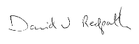

Company Secretary

